**BMSN1601 – Tutorial #3**

|  |  |  |
| --- | --- | --- |
| **Name: Wong Kwok Yin** | **UID:** **3036070362** | **Tutor: Ms Caroline Yang** |

**Tutorial Activities**

* + - Please **complete** and **submit** your answers before the tutorial day via appropriate links on Moodle. The deadline for submission of your work is at 11:59 pm on the day before the tutorial day. (i.e. **Group III: 18 Oct 2022 [Tuesday]; other groups: 19 Oct 2022 ([Wednesday]**). Late submission/ submission to the wrong link will NOT be entertained.
    - During the tutorial students are expected to actively engage in the discussion and answering tutor’s questions. Your tutor will randomly choose students to answer questions.
    - Please refer the instructions and marking criteria posted on Moodle.
    - **NO model answer** will be posted on Moodle.
    - Please also note that the tutorial content may be assessed in mid-term test and/or the final examination.

-----------------------------------------------------------------------------------------------------------------------------------------------

**Part 1: Lecture content review exercise**

Instruction:

*The following question is an example of* ***anatomy*** *questions you will encounter in your final examination. Each SAQ carries 10 marks and you are expected to complete each question in 10 min.*

Question:

The functions of urinary system include excreting waste, regulating electrolyte balance, blood volume and blood pressure.

(a) What structures are located anterior to the left kidney?

|  |
| --- |
| Tail of pancreas, Stomach, Spleen is located anterior to the left kidney |

(b) What are the major arterial supply and venous drainage of the kidney?

|  |
| --- |
| The renal arteries are the major arterial supply which arise from the lateral side of the abdominal aorta, while venous drainage is about paired renal veins drain into the inferior vena cava. |

(c) Where is the urinary bladder located in an adult?

|  |
| --- |
| It locates in lower abdomen, which is at the base of pelvis |

(d) What is the structure that propels urine from the kidney to the bladder?

|  |
| --- |
| Urethra. |

Total: 10 marks

**Part 2: Contextual Learning**

Instruction:   
*The aim of this session is to make connections between knowledge and its applications to your clinical work. Please read the scenario and try answering the questions before you come to the tutorial.*

Scenario:

Mr Chan, a 45 year-old patient with a history of chronic renal disease, had just undergone a minor operation. Post operatively, Mr Chan was not allowed to have any oral intake (Nil by mouth), so he was receiving intravenous (IV) fluid replacement (0.9% NaCl solution 500ml, Q12H). In the afternoon, you noticed that Mr Chan had pitting oedema over his ankles. You found that the IV fluid infusion was running much faster than the prescribed rate. Mr Chan’s daily fluid balance chart was shown in as follow:

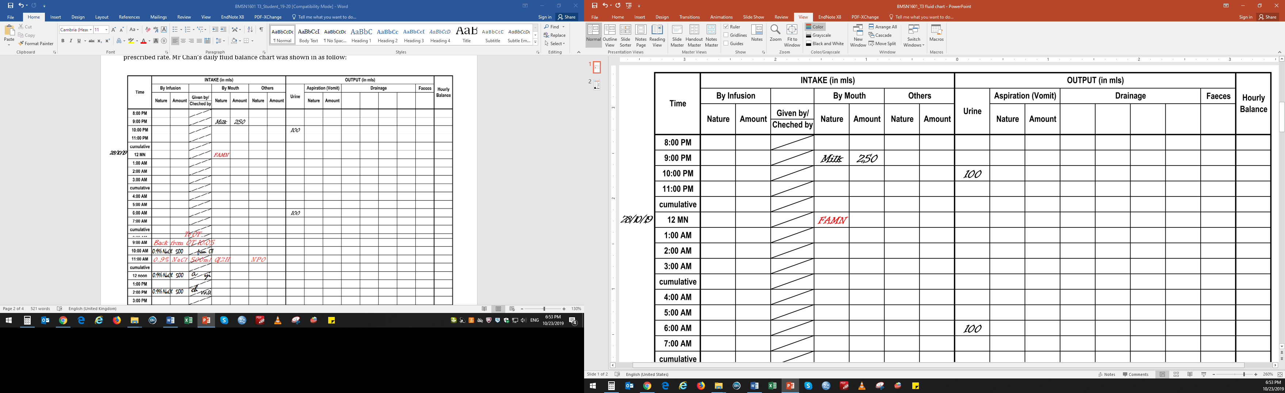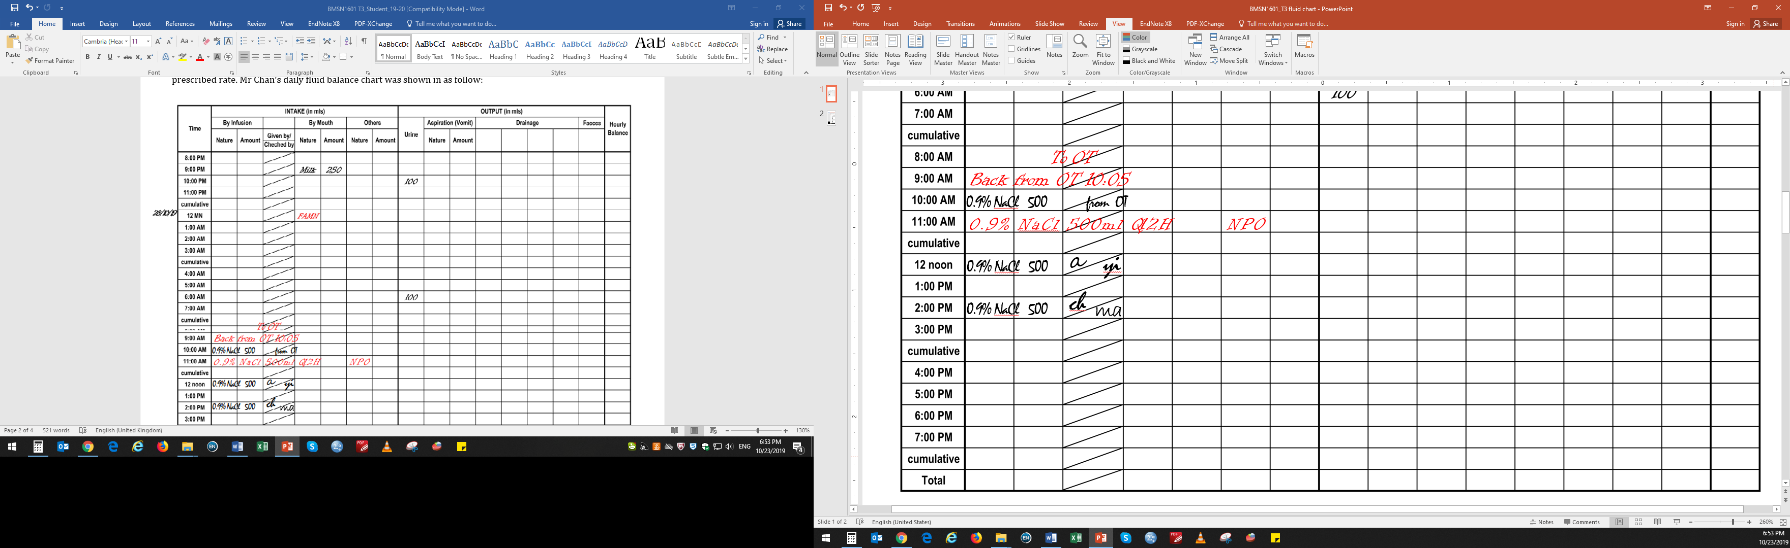

**Discussion Questions**

1. What does it mean by pitting oedema?

**Pitting oedema is a pit which becomes swollen part after pressing for several seconds**

1. What is chronic renal disease? How does this disease affect glomerular filtration?

**It is a long-term disease which kidney is not functioning in a proper way for a long time. It lowers the rate of glomerular filtration rate.**

1. Bulk flow is mass movement of fluid (and its solutes) across the capillary wall. Filtration is the movement of fluid from capillary into tissue while reabsorption is the movement of tissue fluid into the capillary. Explain the forces that govern the direction of such fluid movement.

**During filtration, high glomerular hydrostatic pressure, which is much higher than the sum of blood colloid osmotic pressure and capsular hydrostatic pressure, forces fluids and solutes out of the blood. During reabsorption, the hydrostatic pressure in capillary is less than blood colloid osmotic pressure.**

1. Explain why ankle oedema occurs in Mr Chan.

**Excess body fluid is accumulating in Mr Chan’s ankle as it is not being removed**

1. Suggest three additional pathophysiologic mechanisms of oedema which may happen in other patients.

**the increase of capillary hydrostatic pressure, decrease of plasma oncotic pressure, enhanced hydraulic permeability of capillary walls, and lymphatic obstruction**

1. What are the ordinary (non-disease) factors that can influence fluid balance?

**dehydration, sweating, overhydration**

1. How does hypothalamus play a role in maintaining homeostasis if sodium intake is increased (e.g. after a salty meal)?

**Hypothalamus alters water retention and facilitate excretion of sodium and control the secretion of renin by the kidney to decrease the sodium level in the body. Besides, hypothalamic sensors reacting to sodium concentration by sending the signal of thirsting.**

1. What is aldosterone? What are the functions of aldosterone?

**Aldosterone is a steroid hormone from adrenal glands. It can regulate blood pressure by acting on kidney and the colon to increase the amount of salt reabsorbed into the bloodstream. At the same time, it can increase the amount of potassium excreted in the urine.**

1. Define hypertonic, isotonic and hypotonic solution.

**Hypotonic solution: a solution that contains fewer solutes than blood.   
Isontonic solution: a solution that contains same amount solute when compared to blood.   
Hypertonic solution: a solution that contains higher solutes than blood.**

1. Are 0.9% NaCl and 3% NaCl solutions hypertonic/isotonic/hypotonic respectively (relative to extracellular fluid)?

**0.9% NaCl is isotonic; 3% NaCl is hypertonic**

1. What would happen to the size of body cells when 3% NaCl is administered? Explain your answer.

**As blood contain around 3% NaCl (hypertonic solution), water inside the body cells move out from the cell through osmosis. Hence, body cells become shrink and decreased in cell size.**

1. Given your knowledge on tonicity of intravenous fluid, what will happen to Mr Chan’s fluid balance if he is administered with 3% NaCl?

**Mr Chan has a disease history of chronic renal disease, which shows his kidney cannot functioning properly in terms of lower rate of glomerular filtration, so she is unable to remove excess body fluid and metabolic waste. Thus, Mr Chan’s fluid can be understood as hypertonic solution than normal body fluid. With the use of 3% NaCl, it has similar osmolarity when compared to Mr Chan’s fluid, the rate of intravenous fluid infusion would be similar to prescribed rate.**